Tianyi Wang

Nov 19, 2019

Assignment 08

Product List

**Product List**

**Introduction**

A starter script was given with pseudo-code and the purpose of this lab is to modify the starter script to make the application work. Class method is mainly used in this lab.

**Class Product**

For Class Product, I added two fields which are product name and product price. Followed Professor Root’s notes, attributes, properties and methods were added into the script as well, shown in Figure 1 and Figure 2. Error handling is also included under product name’s property.

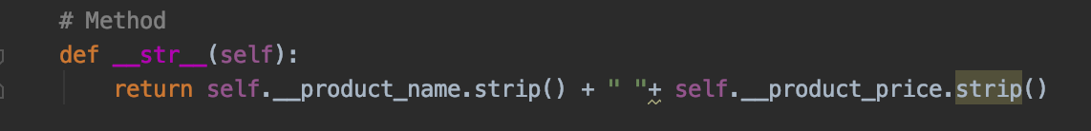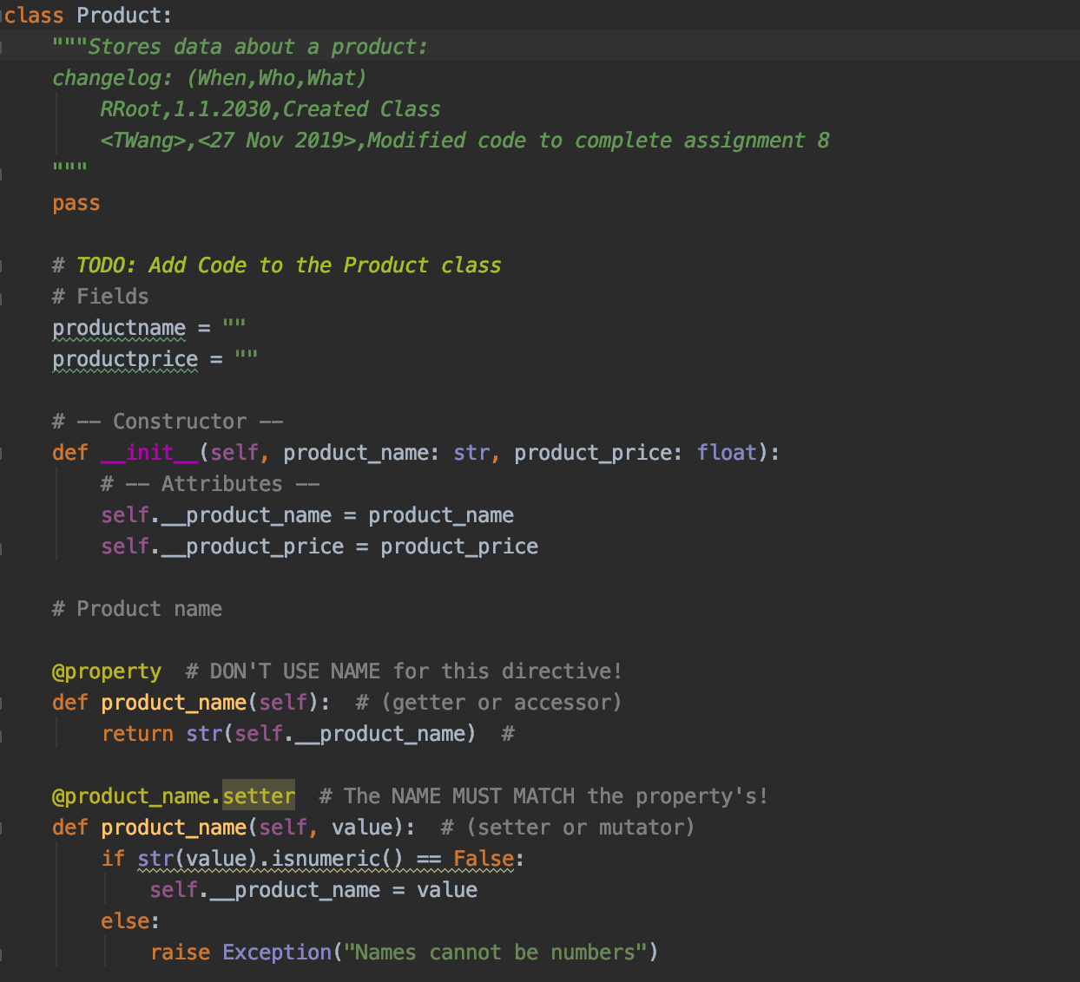

Figure Class Product

Figure Class Product

**Class FileProcessor:**

According to the starter, two file processes are needed for this lab. First, it’s to save data into a file and second is to retrieve data from a file and display the data back to the user. In this case, I created two define functions to fulfill the needs shown in Figure 3. 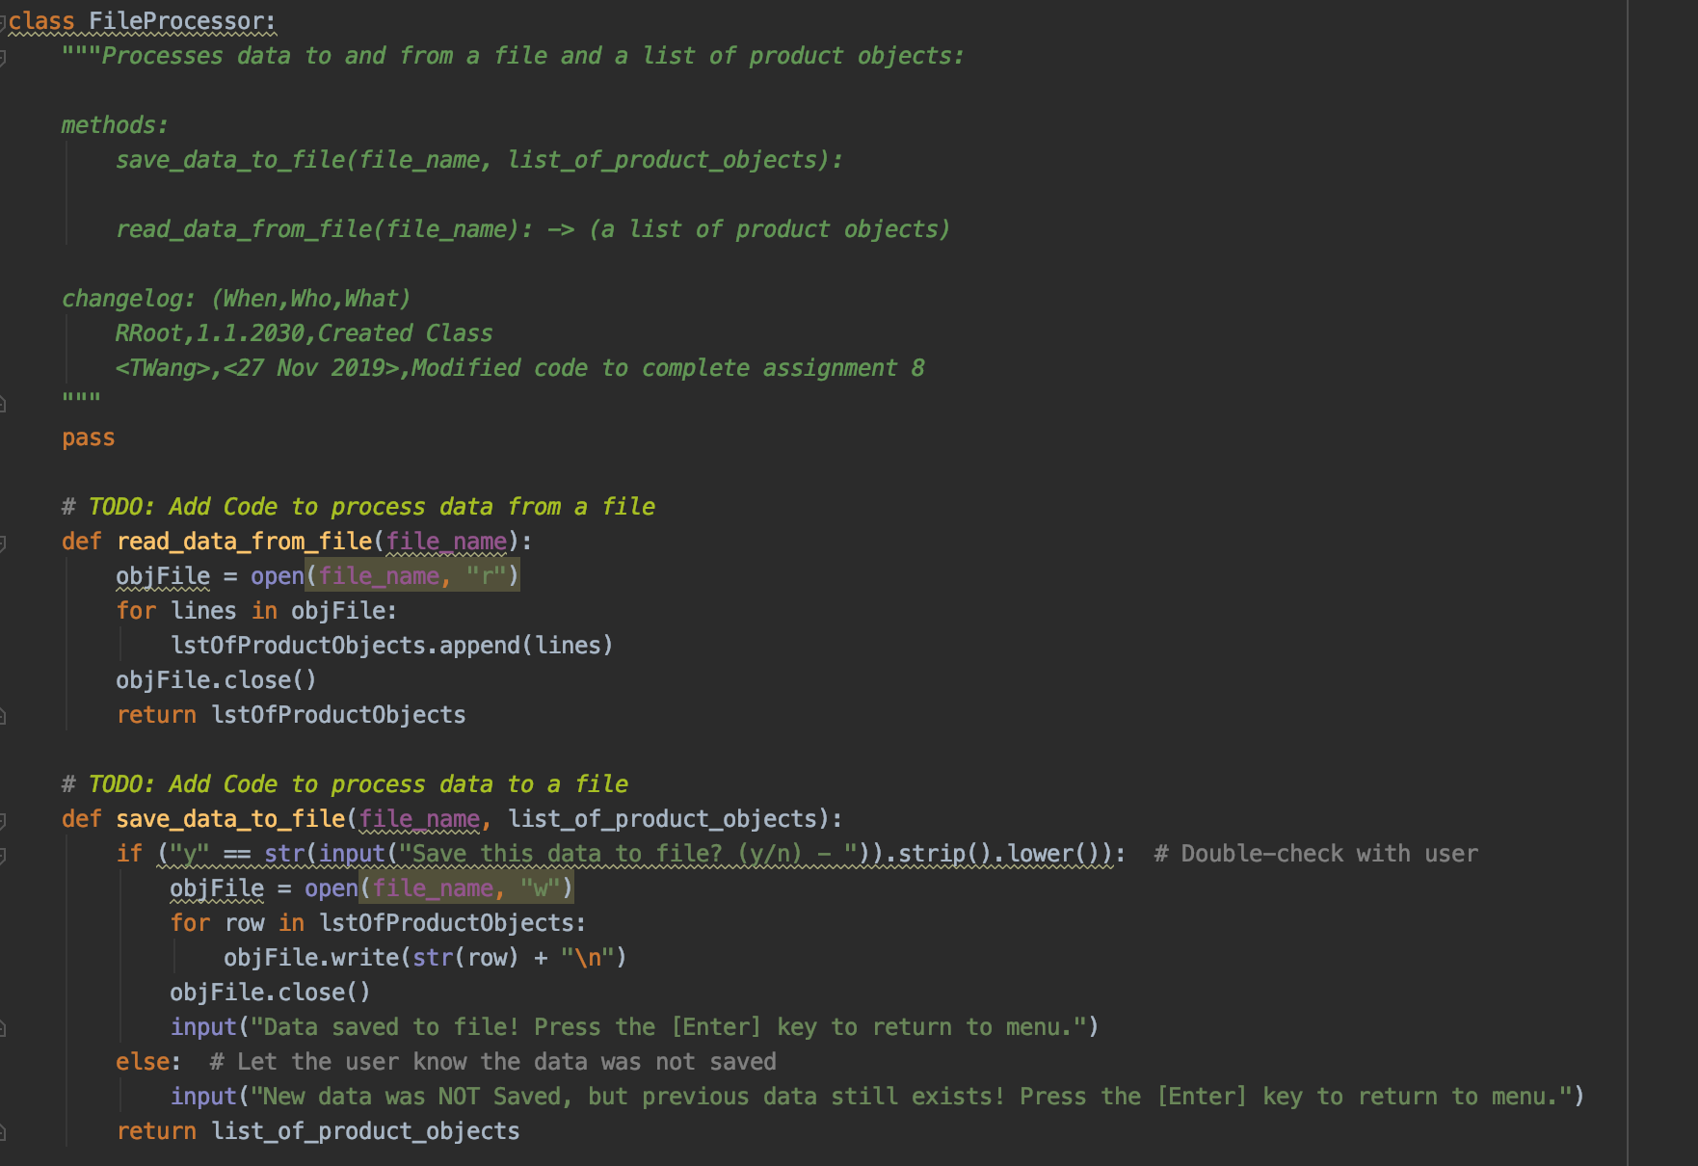

Figure Class FileProcessor

**Class IO(Input and Output):**

Under this class, I made up several functions to allow user to input and see the output from running the script. First, I made a menu and an input menu choice so this would allow the user to choose from the options. Then, I created two more functions that could display the data back to the user from a file and allow the user to make inputs. All the functions described above are shown in Figure 4.

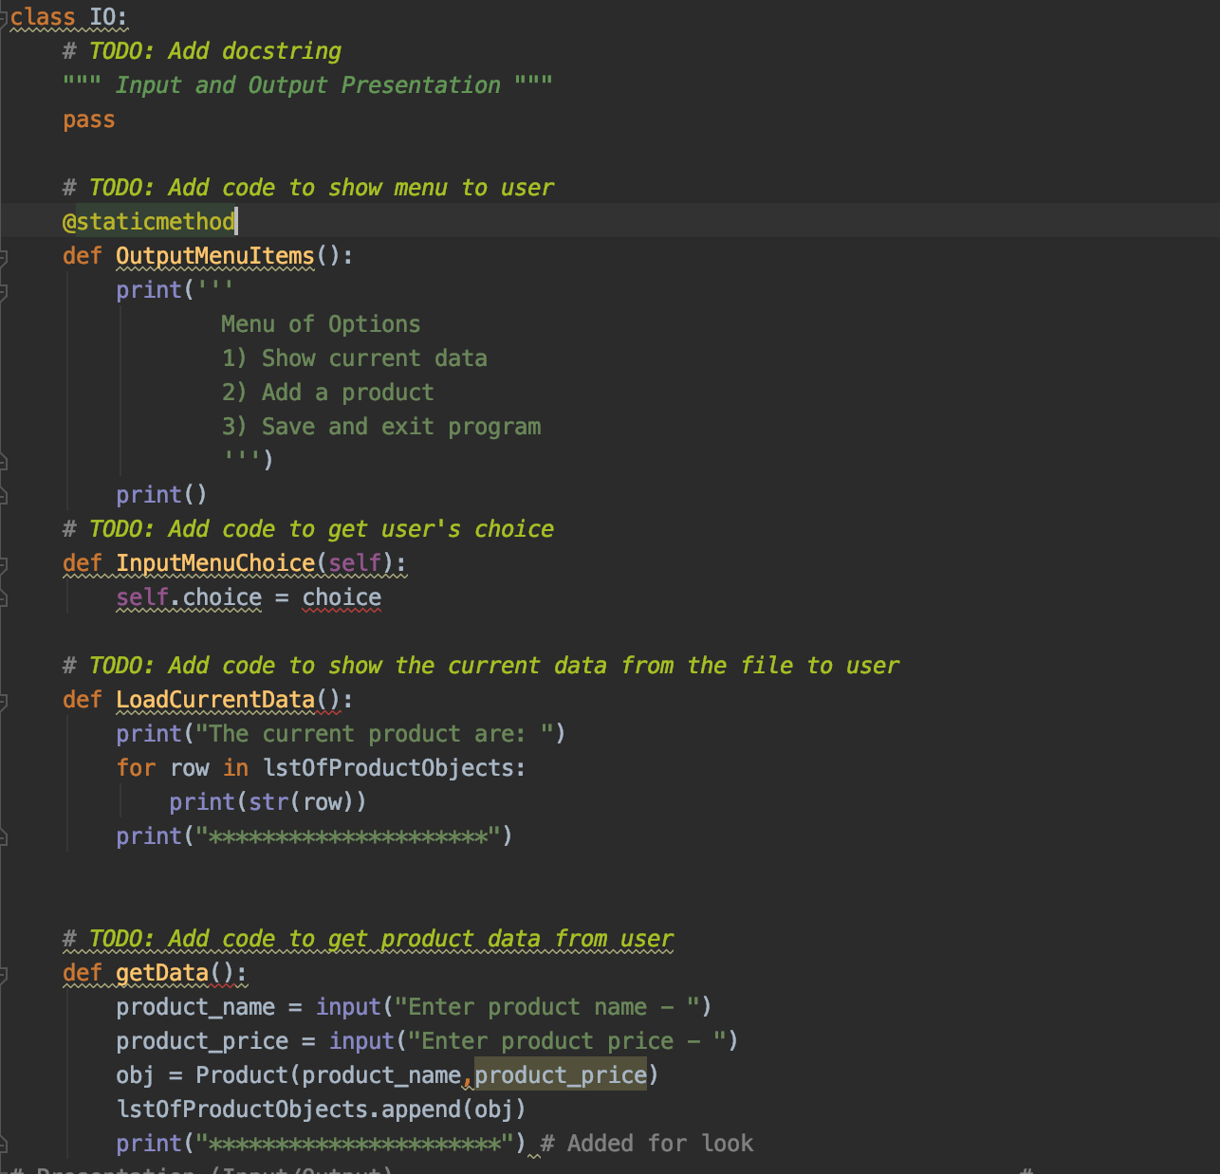

Figure Class IO

**Main Body**

Main body part will allow the user to choose from the menu, add product and get current data that is in the file by calling different defined functions. Figure 5 shows how to call different functions and error handling is also included.

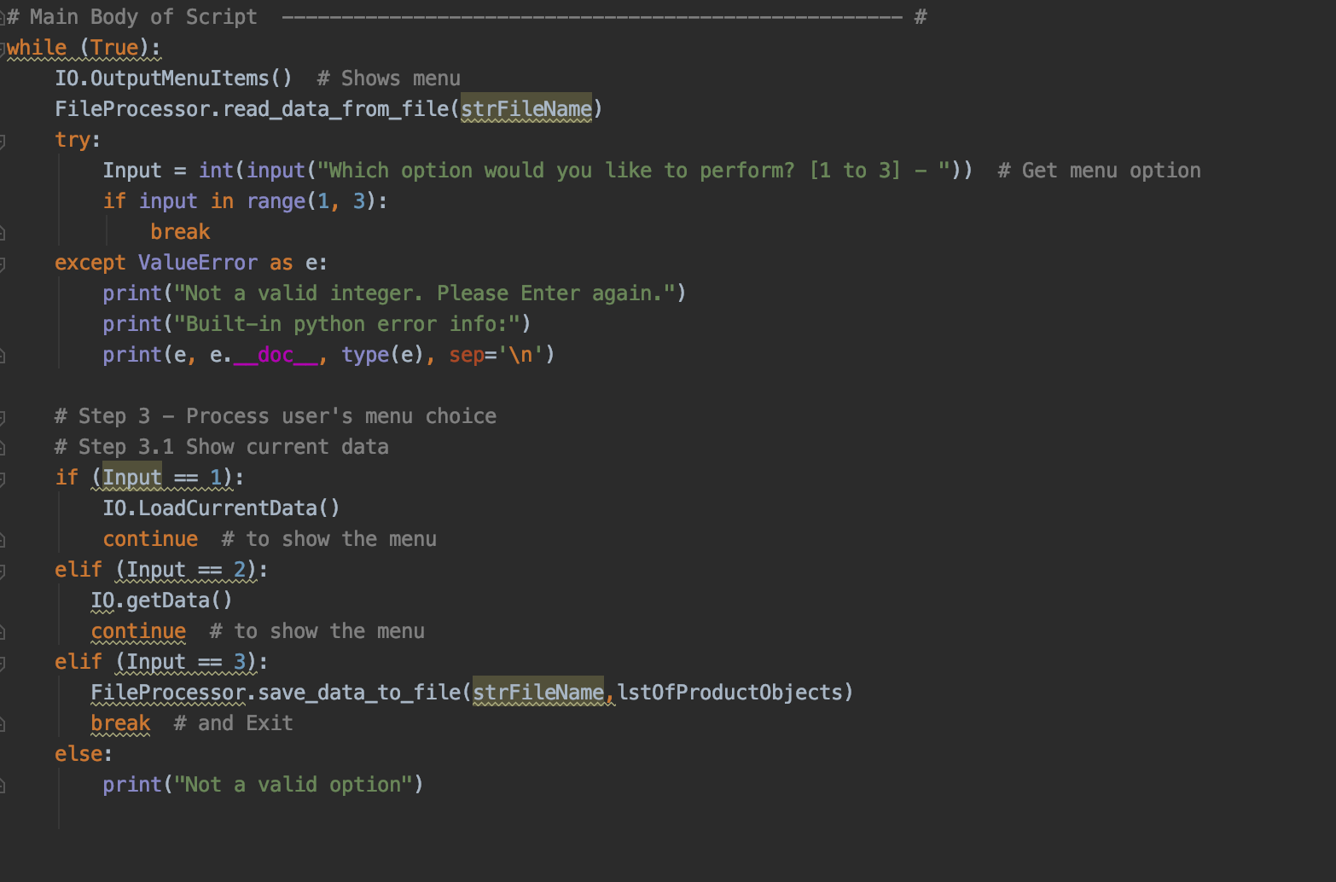

Figure Main body

**Result**

In Figure 6 and Figure 7, I was able to enter option, add data and get current data display back to me. Also, if I entered an option that is not valid, an error code would show up saying that it’s not a valid option.

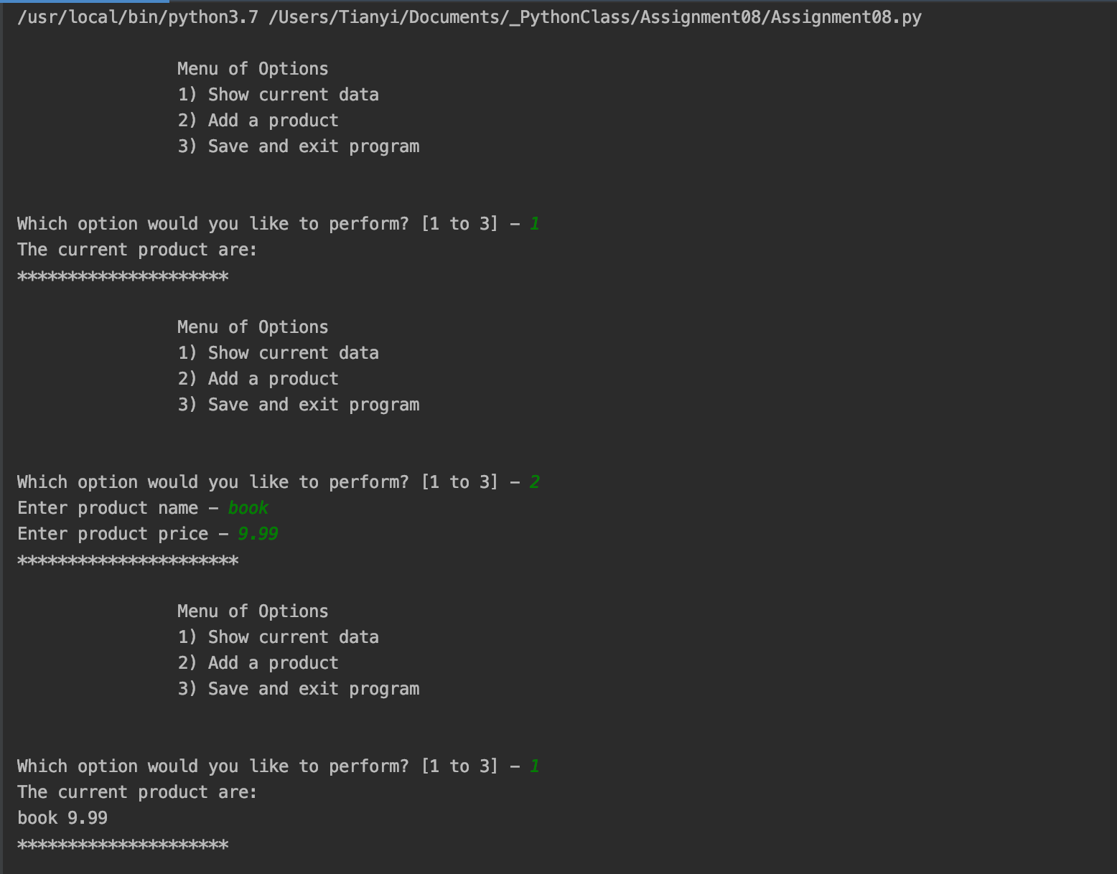

Figure Result

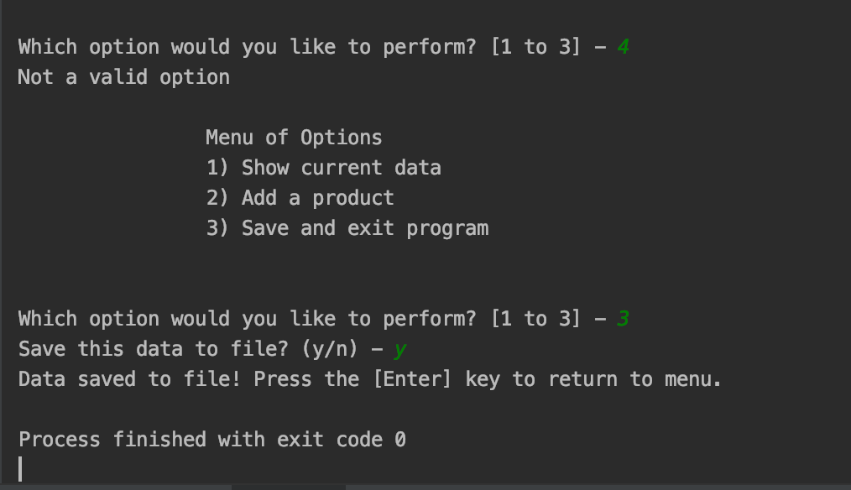

Figure Result

**Summary**

I was able to modify the starter script to make the application work. I mainly used Classes and Define method. Error handling is also included in the script. This script would allow user to add, save and get data from a file.